Task 1
Create one Jenkins job using the below code and create three stages:
Stage1: Git clone to download the source code.
Step 1: Launch an instance, install Jenkins and run public_ip:port_number in browser.
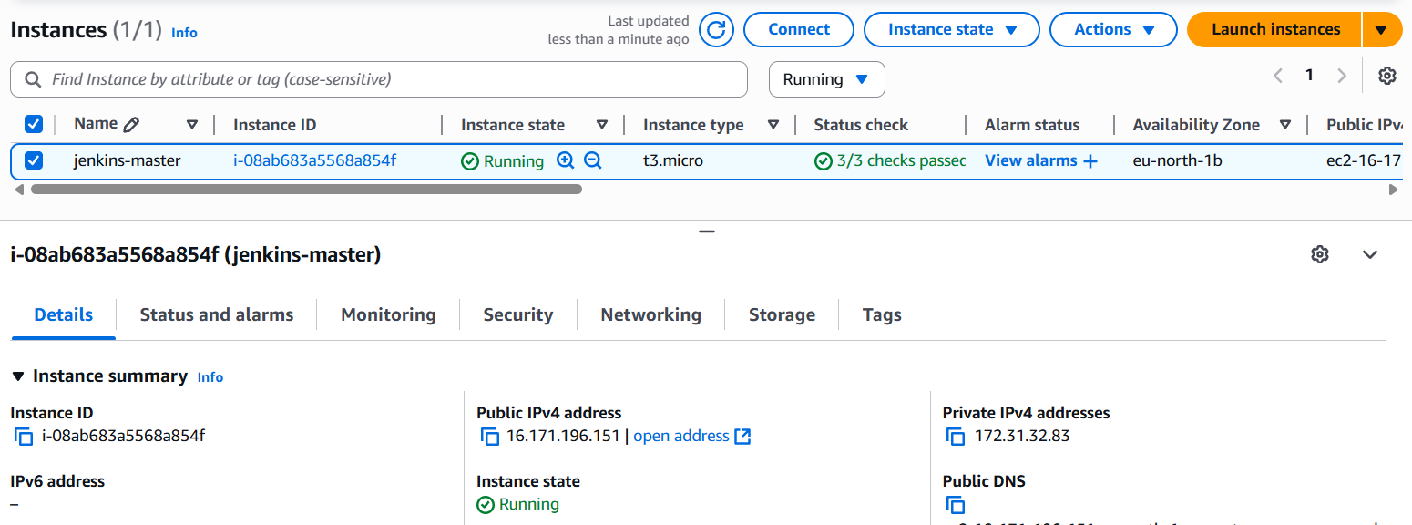
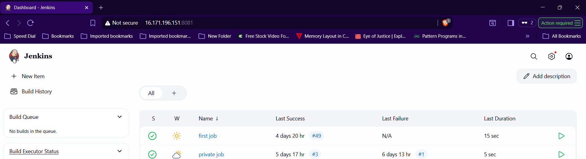
Step 2: Select New itemEnter name, select freestyleselect git and paste repo linksave.
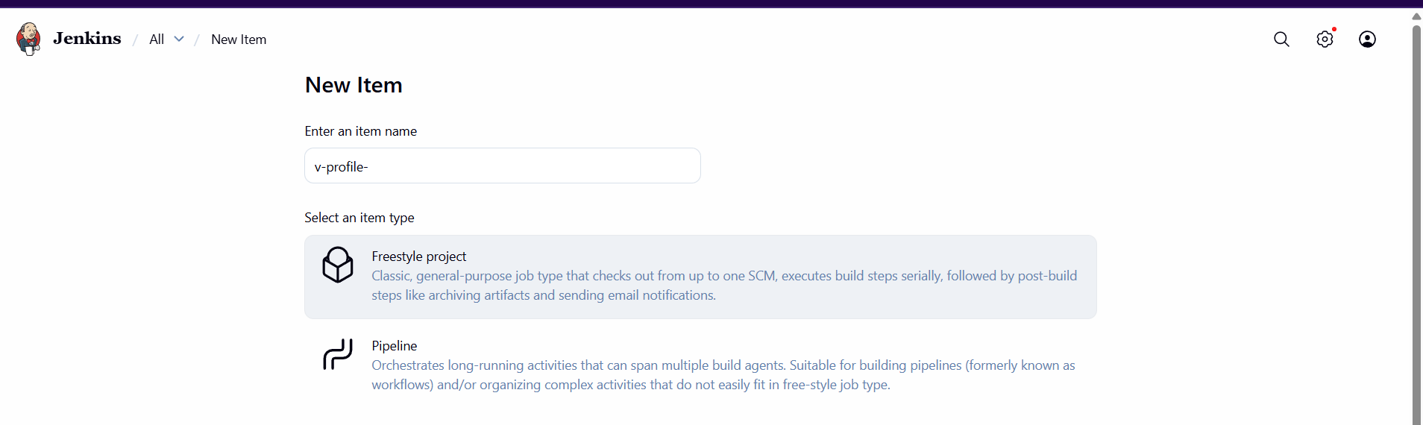
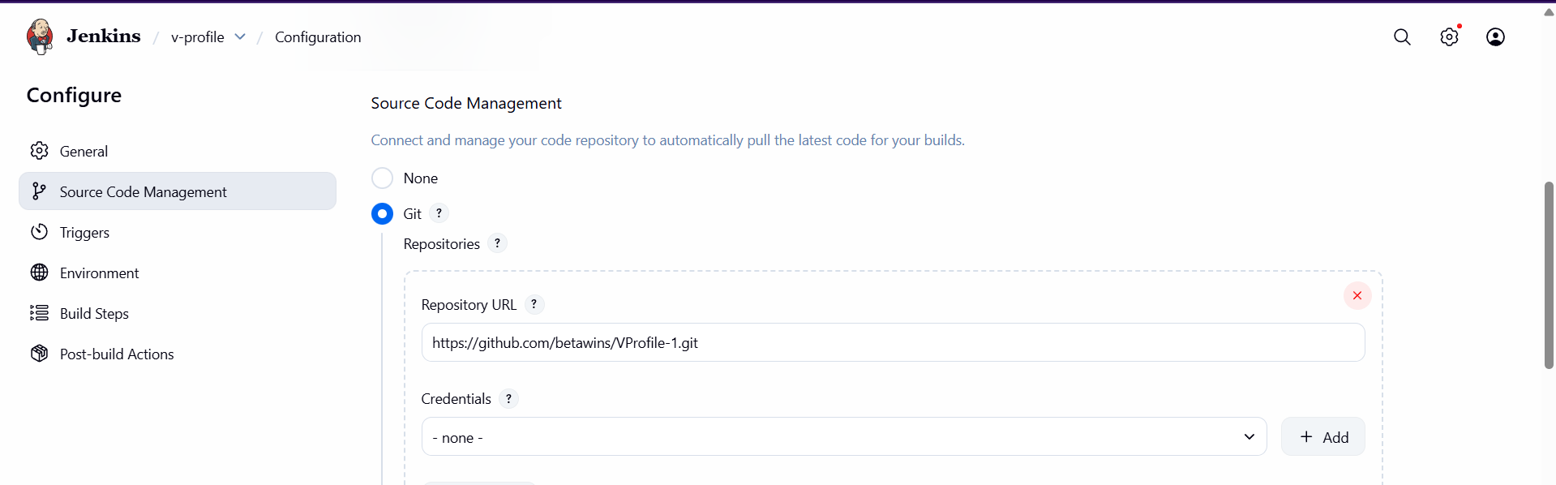
Step 3: Select Build Now.
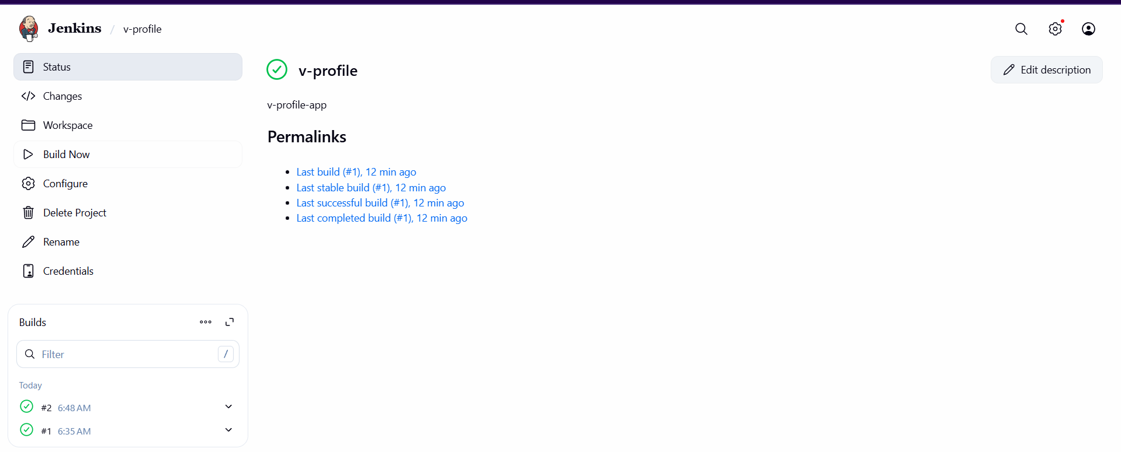
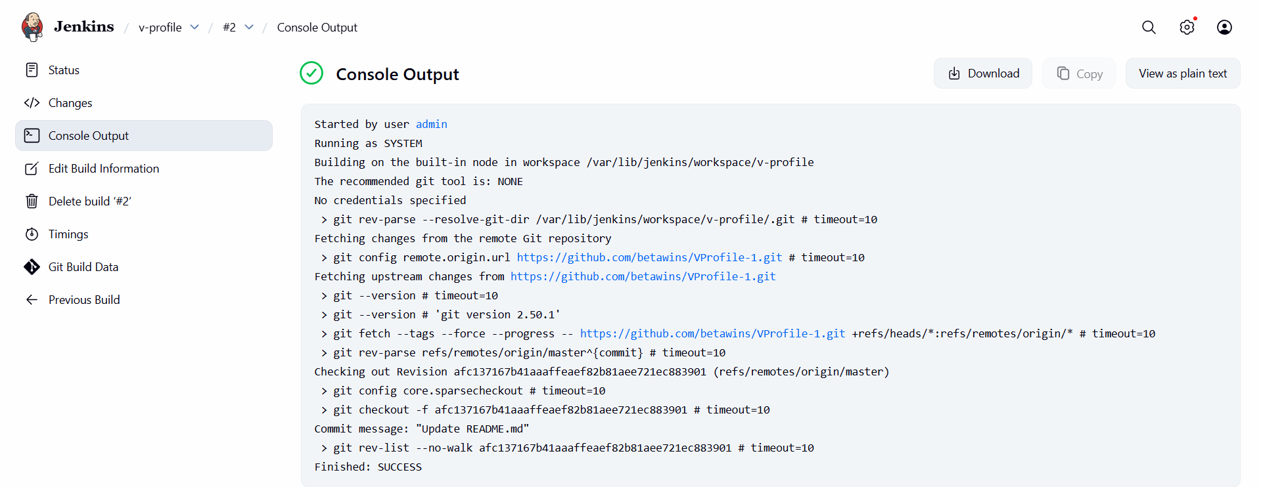
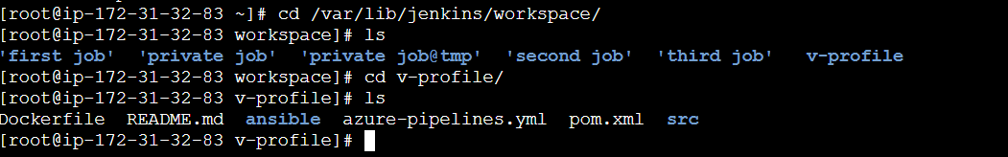
Stage2: Sonarqube Integration to check the quality of code.
Step 1: Launch an instance with 20GB volume, and run following commands.
- sudo yum install docker -y
- systemctl start docker
- docker pull postgres
- docker pull sonarqube
- docker network create sonarnet
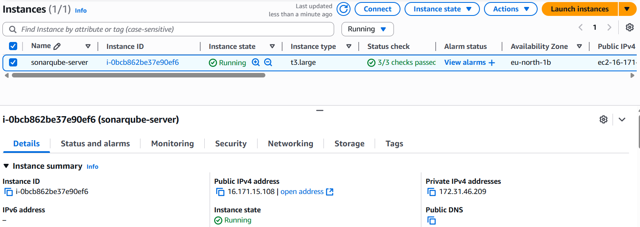
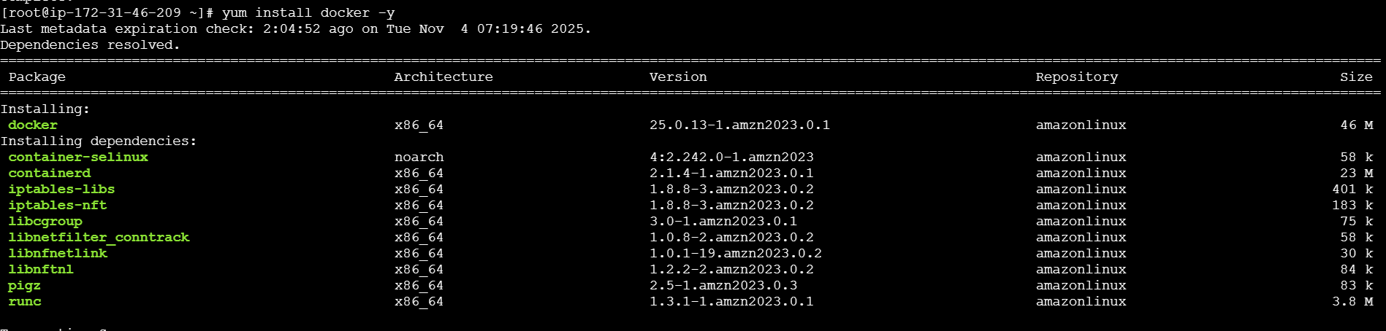
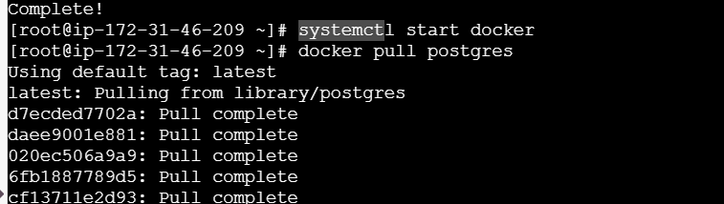
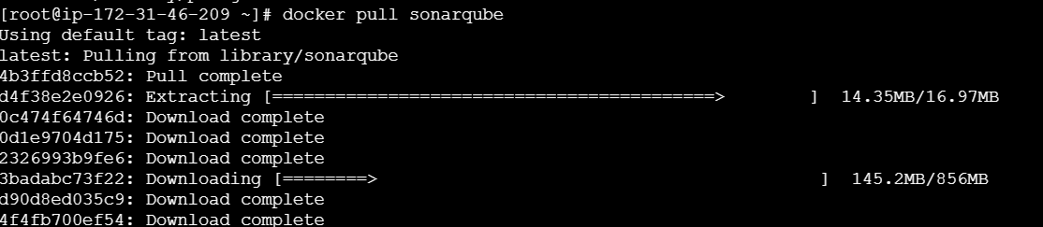
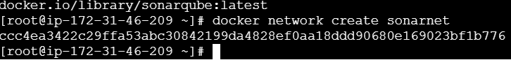
docker run -d --name sonardb --network sonarnet \
-e POSTGRES_USER=sonar \
-e POSTGRES_PASSWORD=sonar \
-e POSTGRES_DB=sonarqube \
-p 5432:5432 \
postgres:15
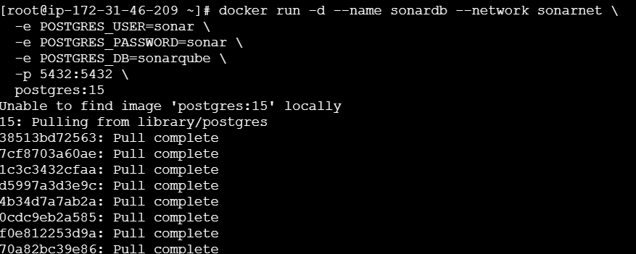
sudo sysctl -w vm.max_map_count=262144
sudo sysctl -w fs.file-max=65536
ulimit -n 65536
ulimit -u 4096
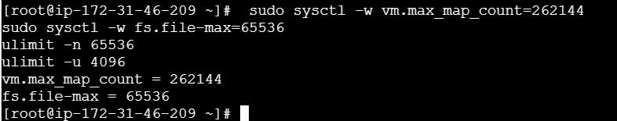
docker run -d --name sonarqube --network sonarnet \
-e SONAR_JDBC_URL=jdbc:postgresql://sonardb:5432/sonarqube \
-e SONAR_JDBC_USERNAME=sonar \
-e SONAR_JDBC_PASSWORD=sonar \
-e SONAR_ES_BOOTSTRAP_CHECKS_DISABLE=true \
-p 9000:9000 \
sonarqube:latest
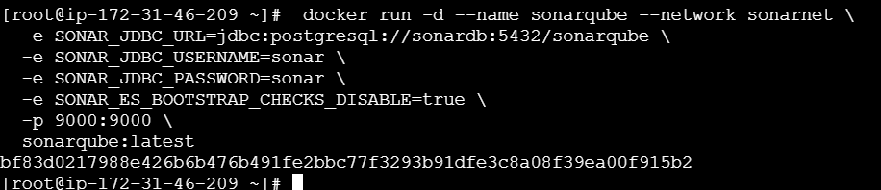
Step 2: Run public_ip:9000 in browser and configure new password.
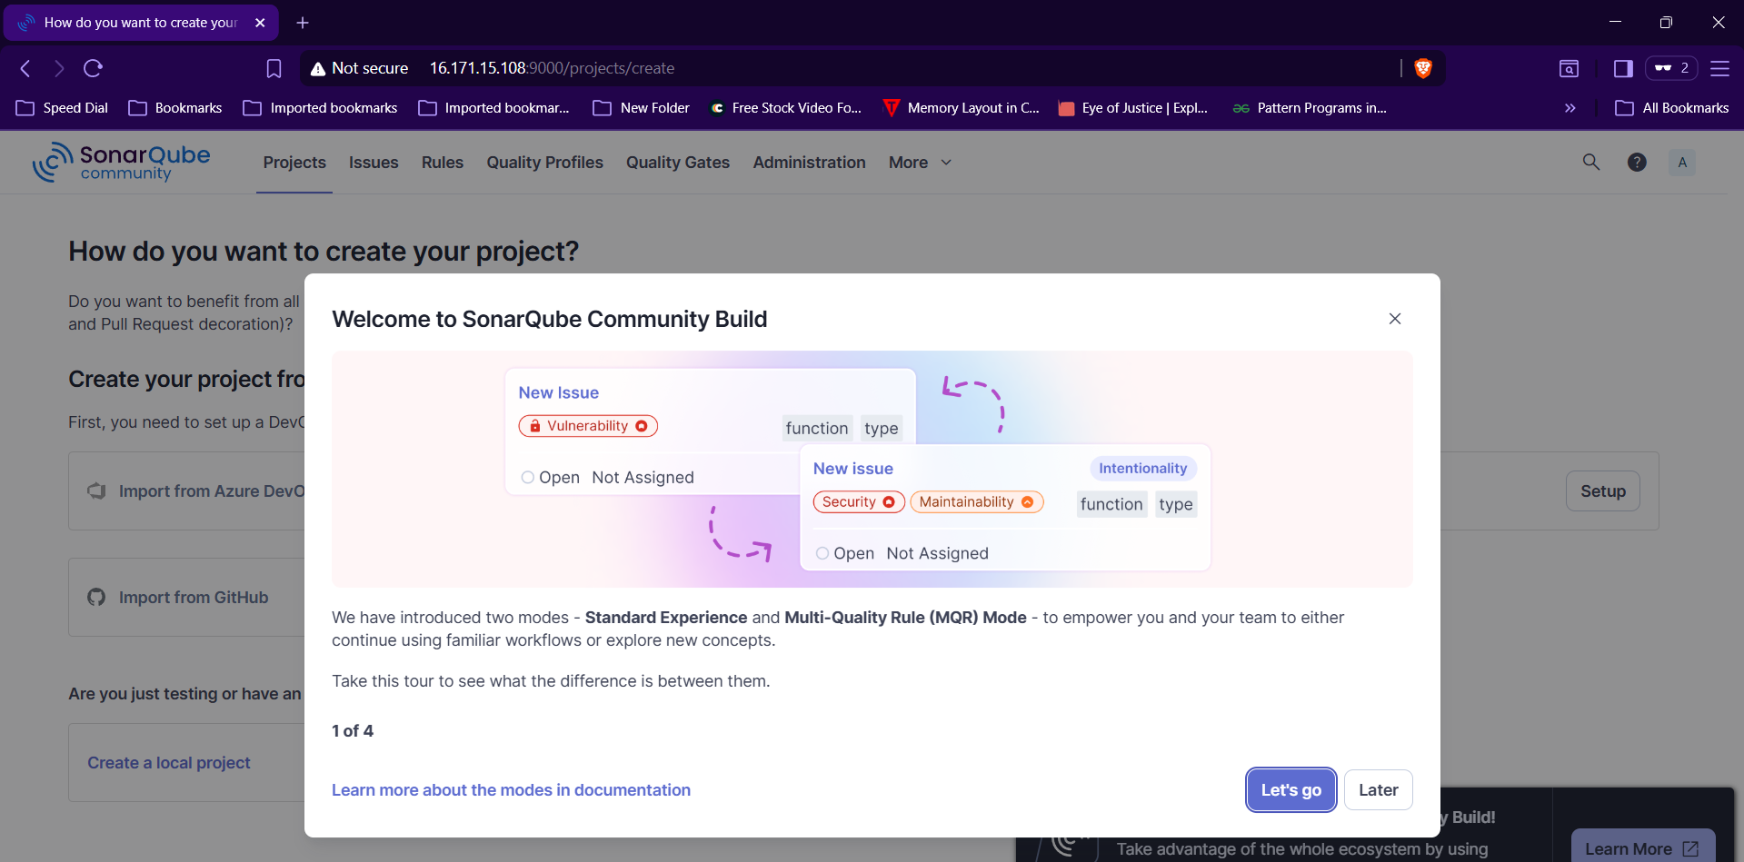
Step 3: Install sonarqube scanner plugin and sonarqube in Jenkins server.
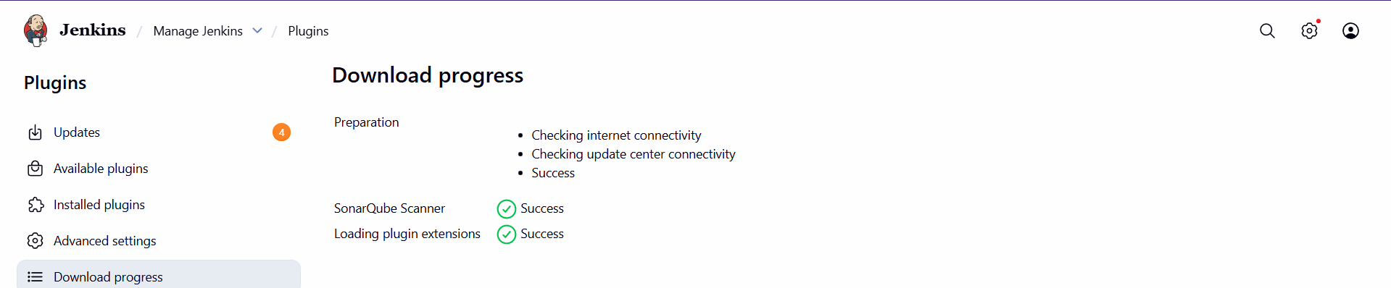
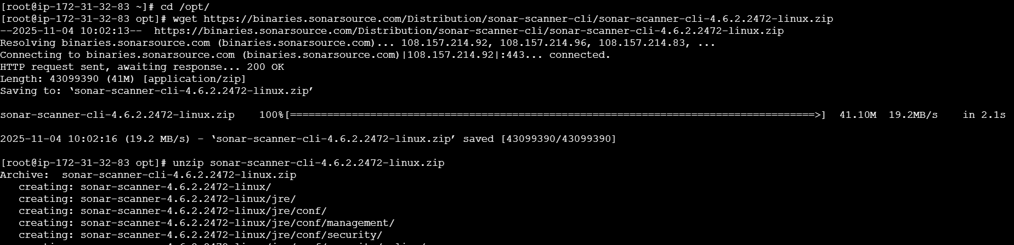
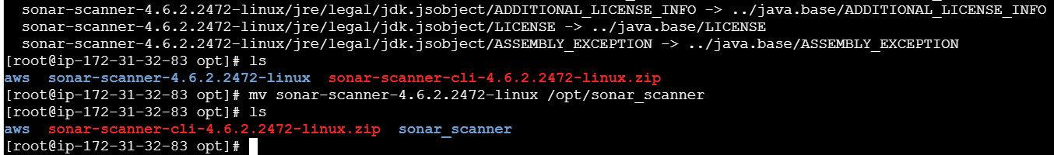
Step 4: change the URL to http://pub_ip_of_sonar_server:9000 in sonar-scanner.properties file
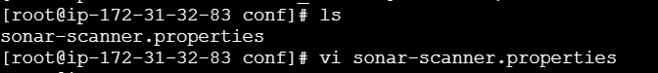
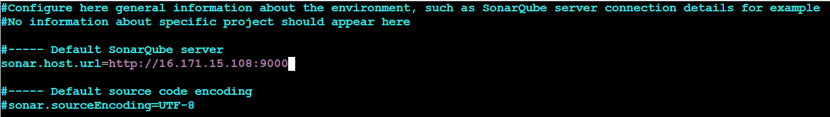
Step 5: Goto Manage JenkinsGlobal Tool ConfigurationSonarQube Scanner and configure home pathsave.
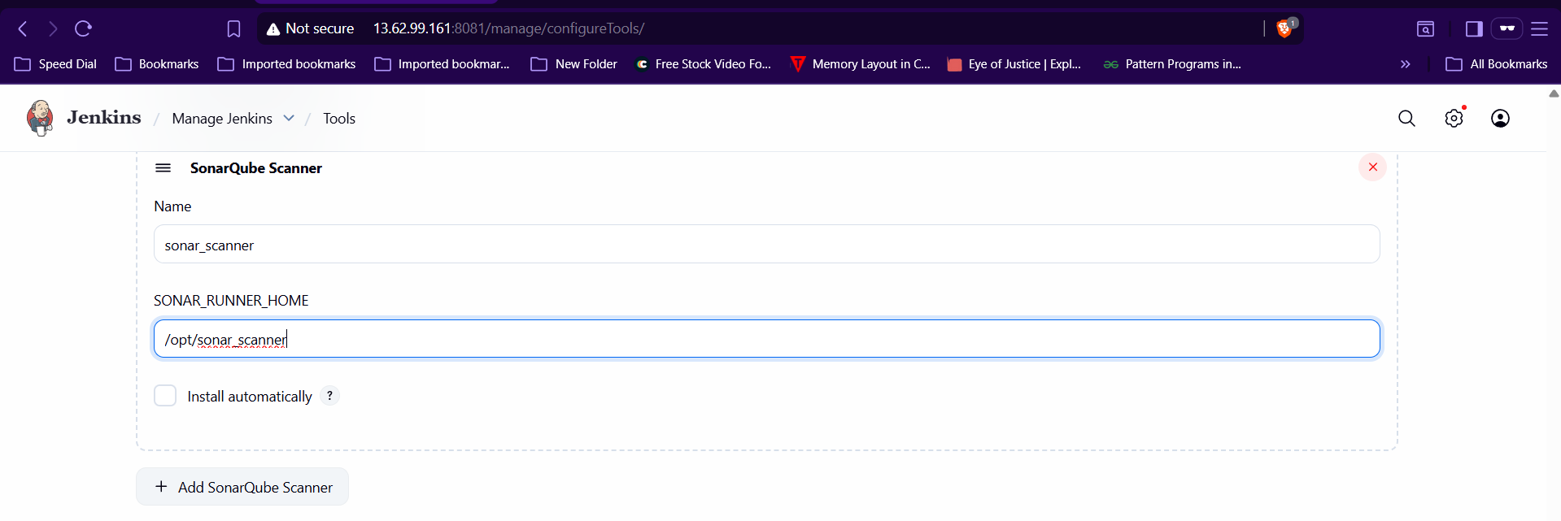

Step 6:Goto SonarqubeMyaccountsecurityGenerate Token.
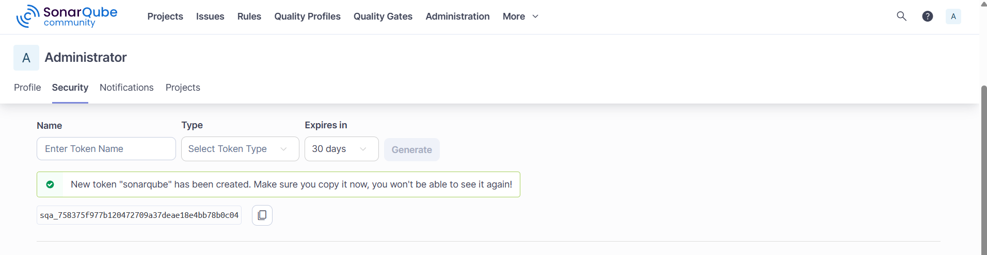
Step 7: Injenkins GUI goto Manage Jenkinssystemsonarqube installationprovide details with token save.
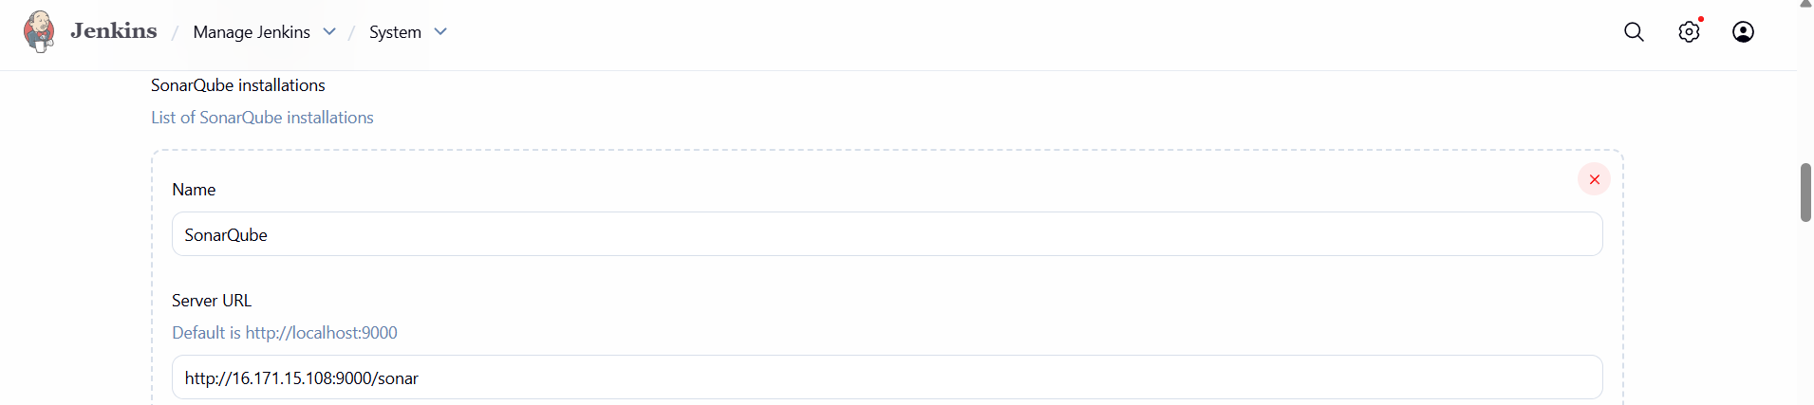
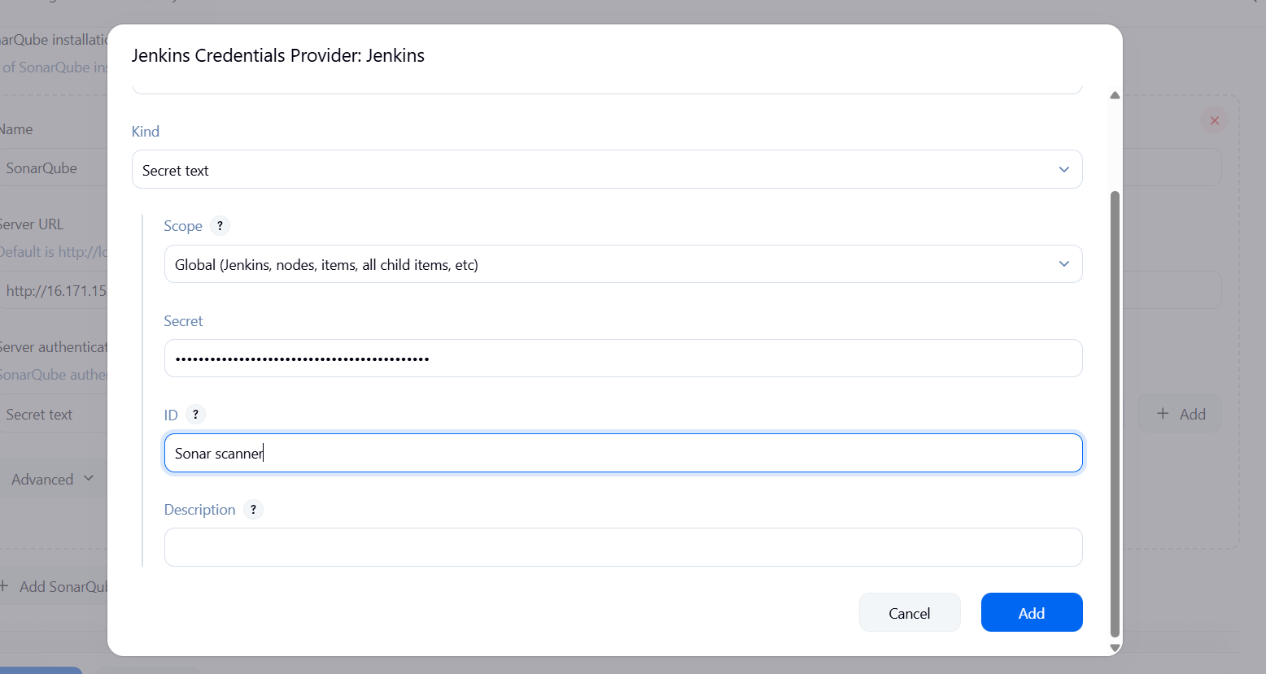
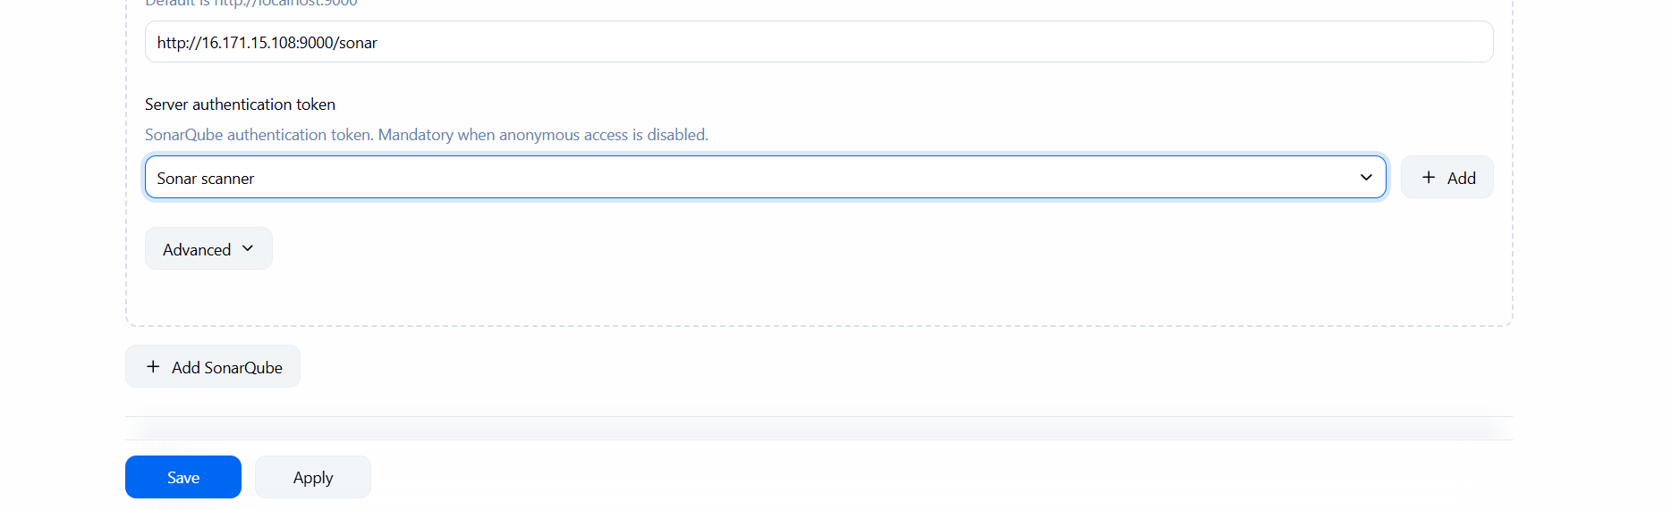

Step 8: Enter analysis report in Execute sonarqube scanner and buid it.
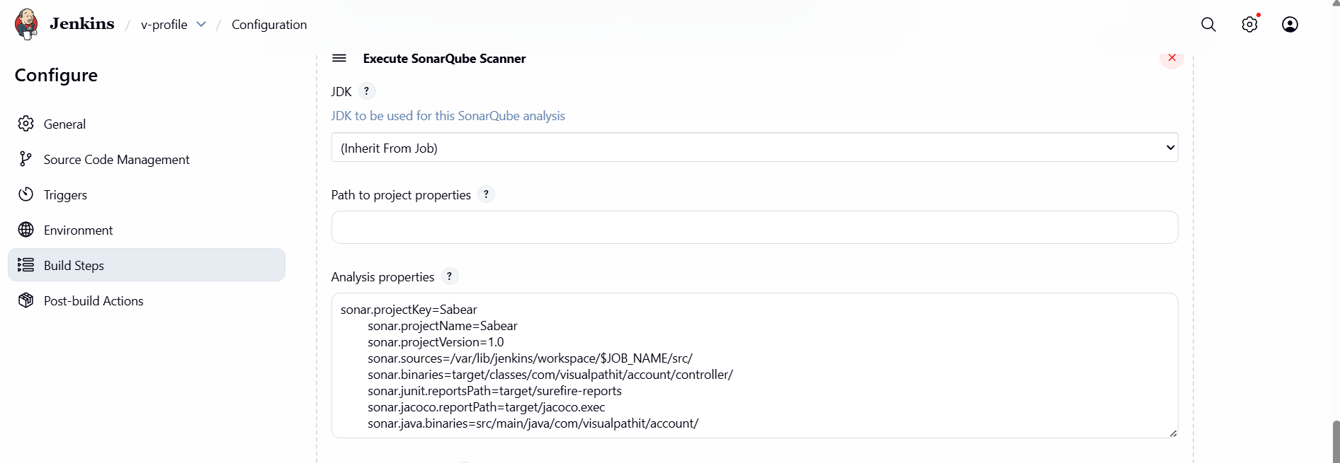
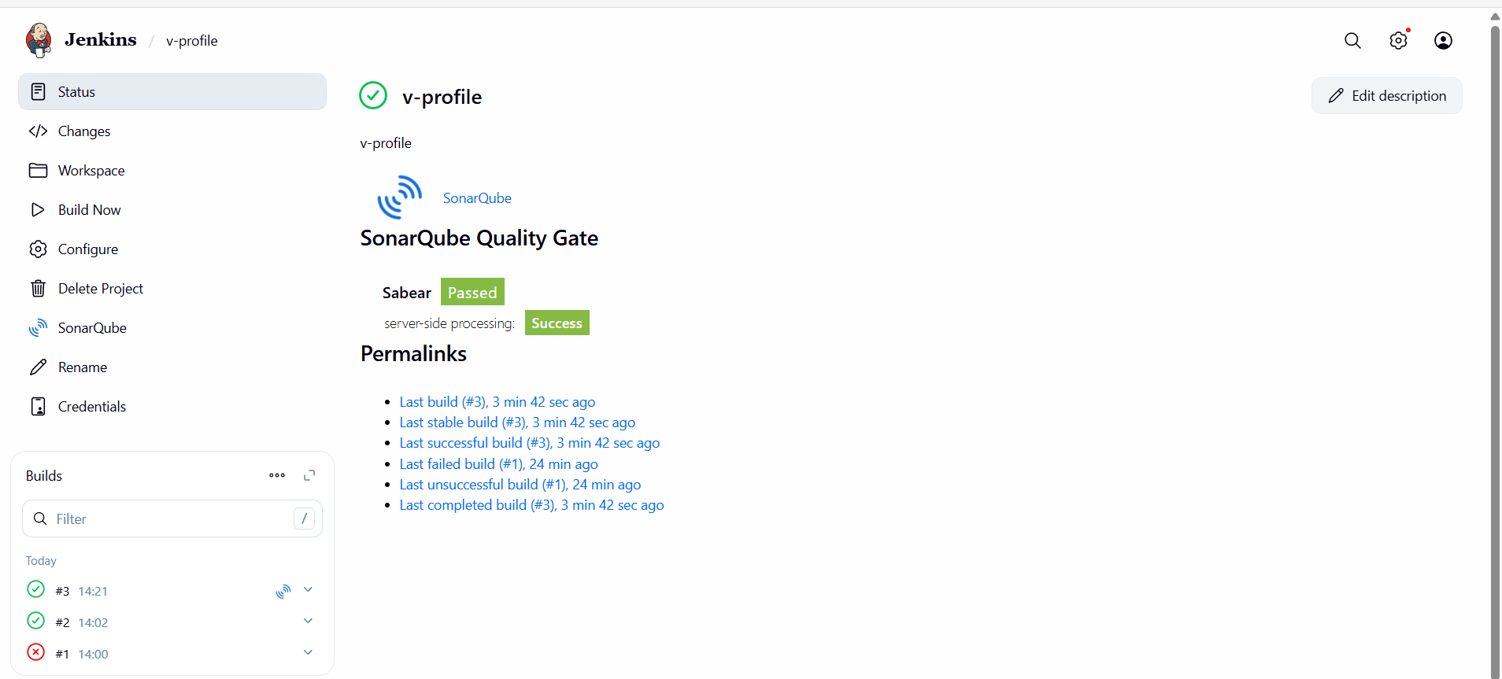
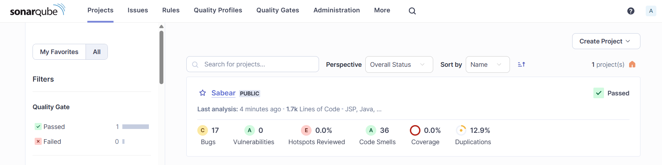

Stage3: Slack Integration to send the alerts to slack.
Step 1: In Jenkins GUI goto Manage JenkinspluginsAvailable plugins download slack notification
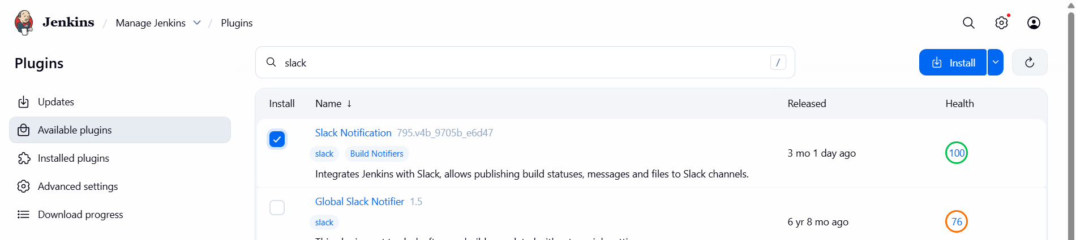

Step 2:Goto SlackAppsmanageBrowse appsJenkins CIconfigurationadd to slackselect channel
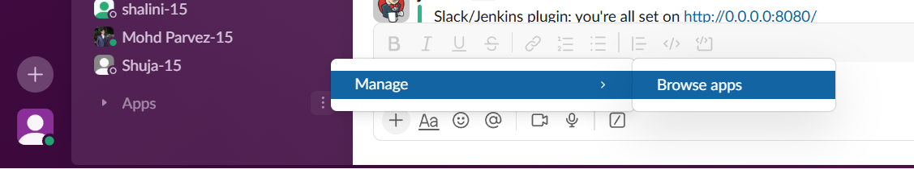
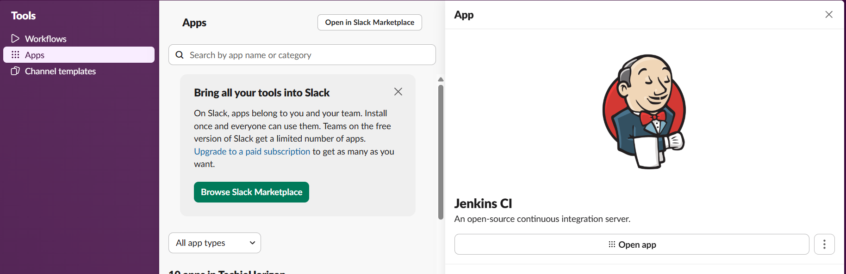
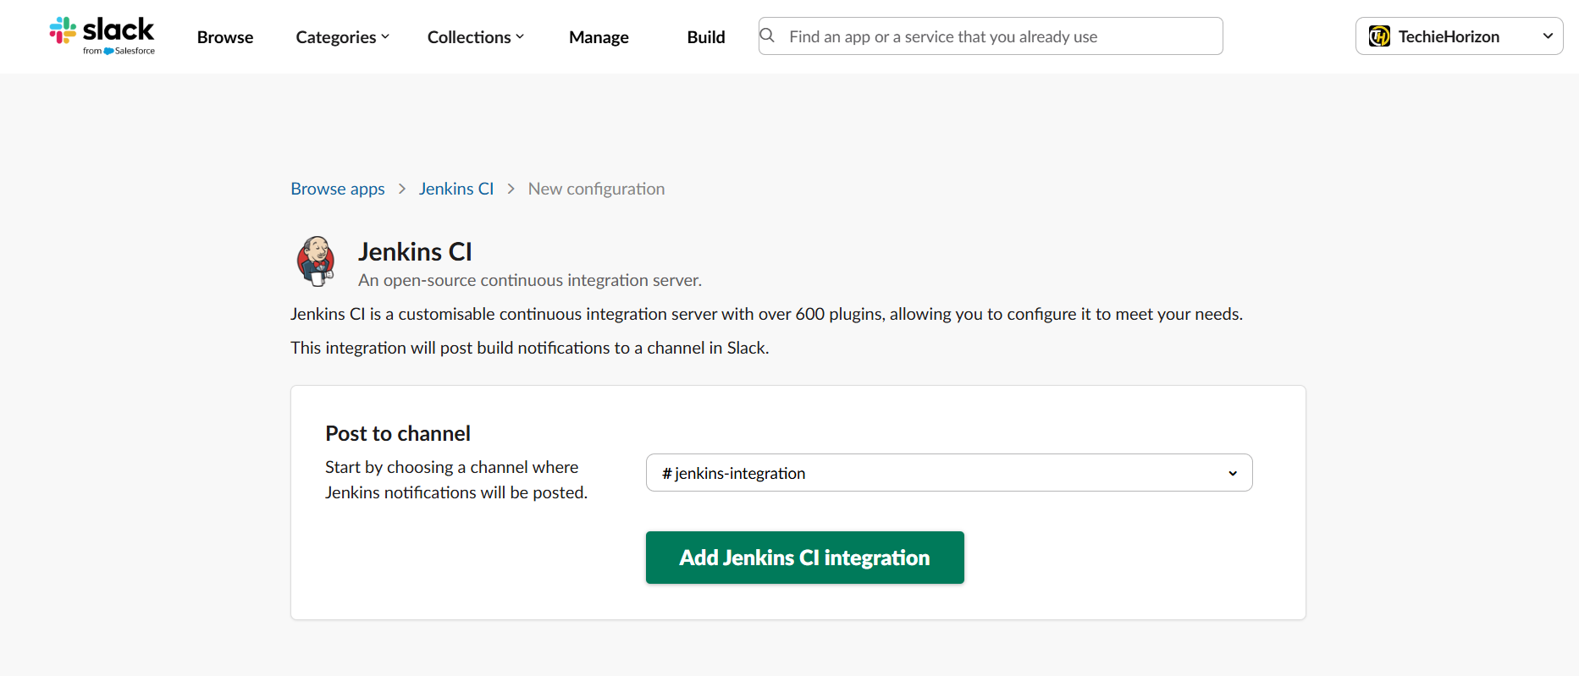

Step 3: Goto Jenkins GUI Manage JenkinssystemslackEnter detailsselect Test connection.
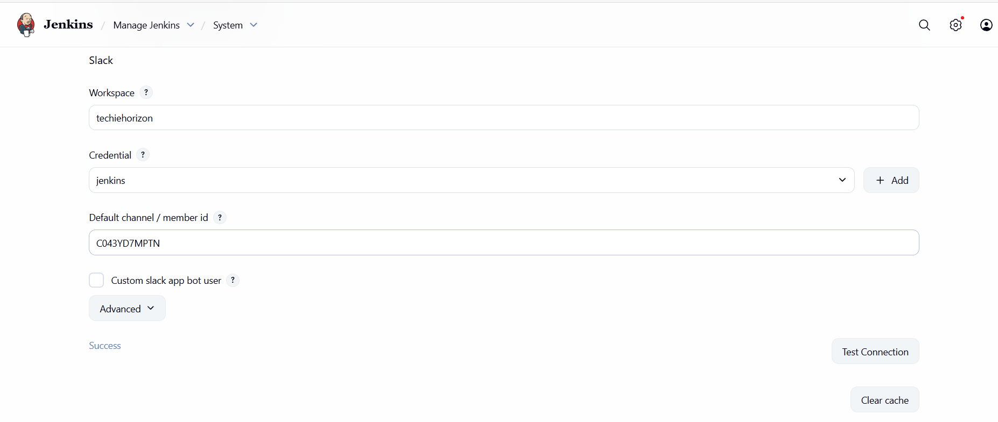
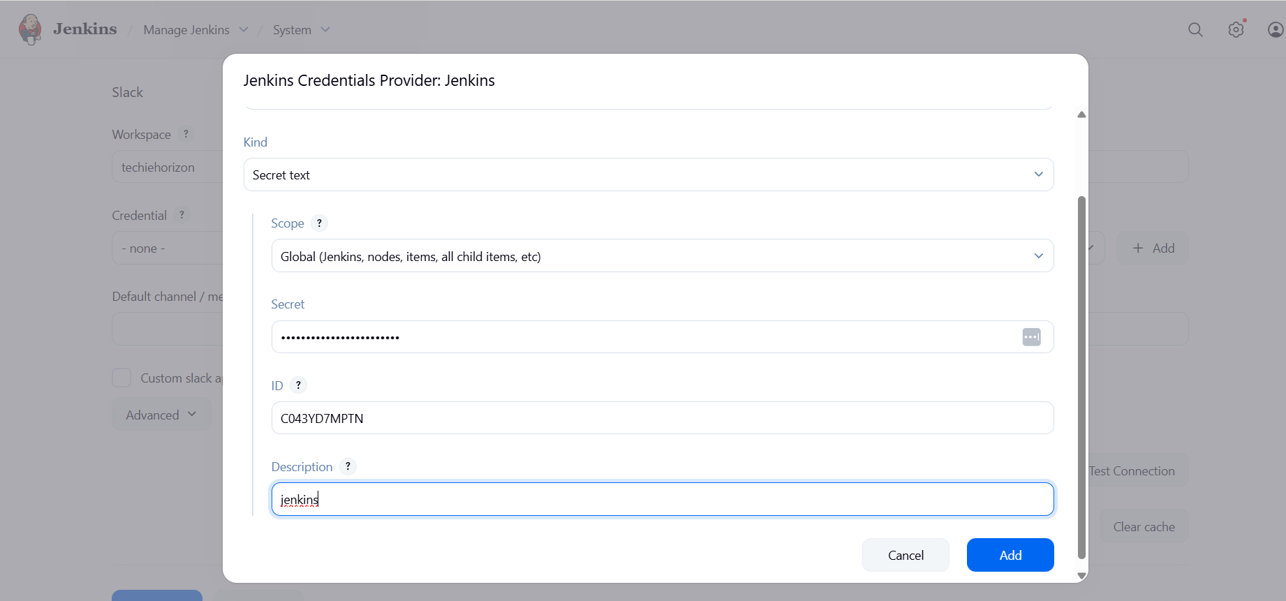
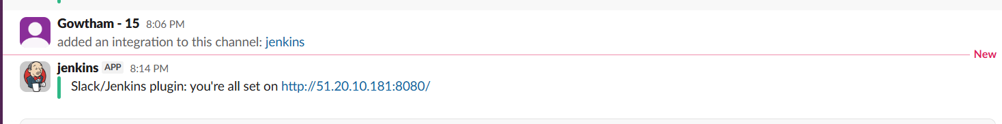

Task 2
Create one Jenkins job using the below code and create three stages:
Stage1: Git clone to download the source code.
Step 1: Launch an instance, install Jenkins and run public_ip:port_number in browser.


Step 2: Select New itemEnter name, select freestyleselect git and paste repo linksave.
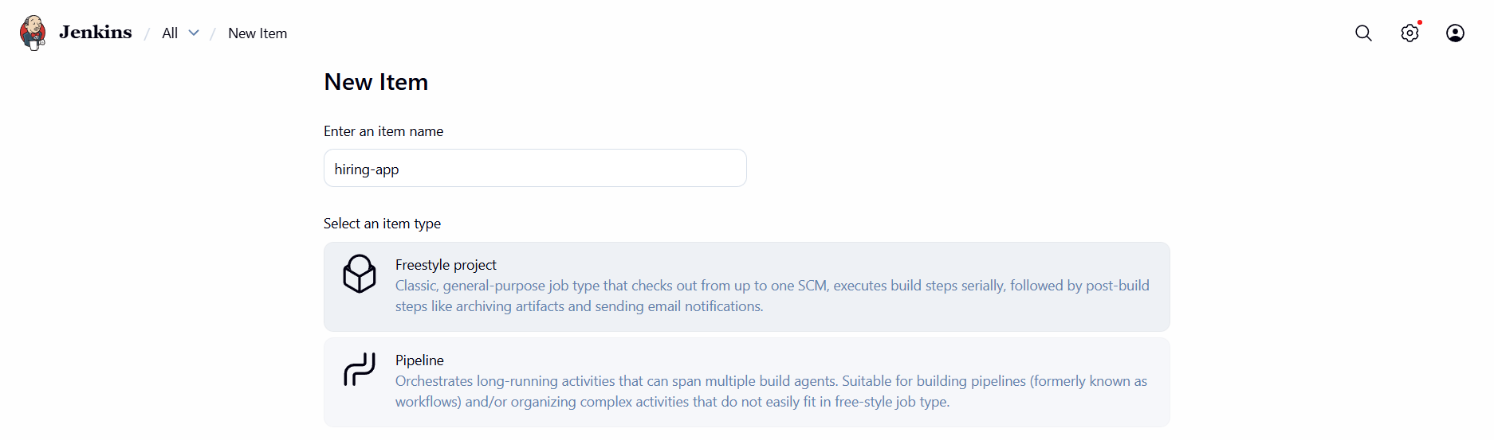
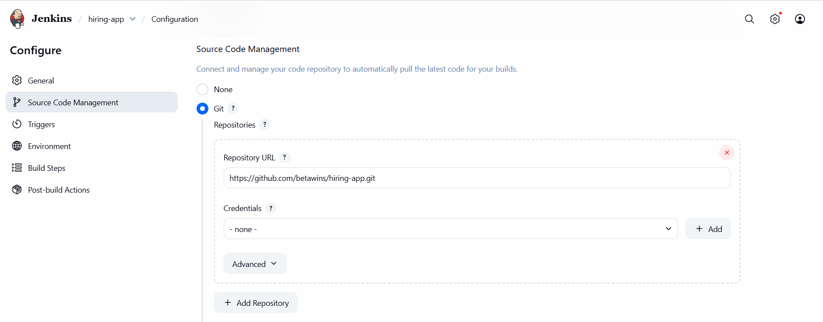
Step 3: Select Build Now.
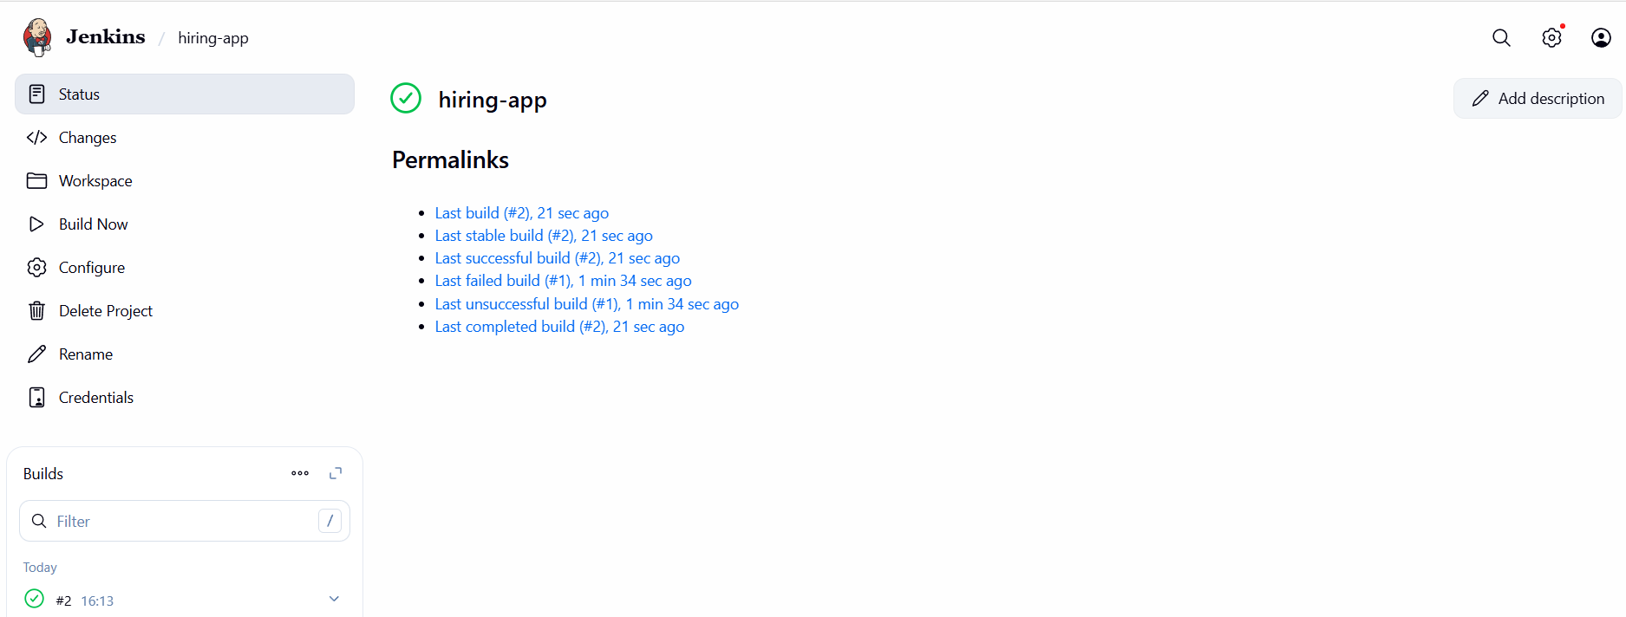
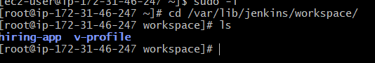

stage2: Sonarqube Integration to check the quality of code.
Step 1: Goto jobconfigureBuild stepsExecute sonarqube scannerenter scriptsave.
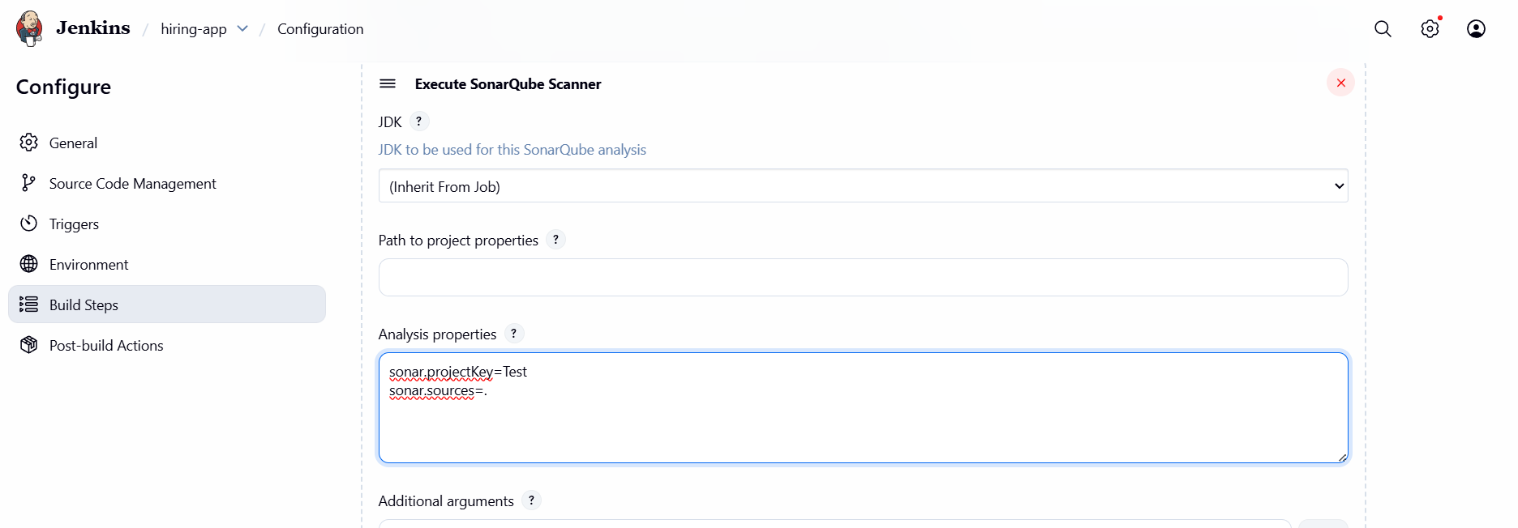
Step 2: Select Build now.
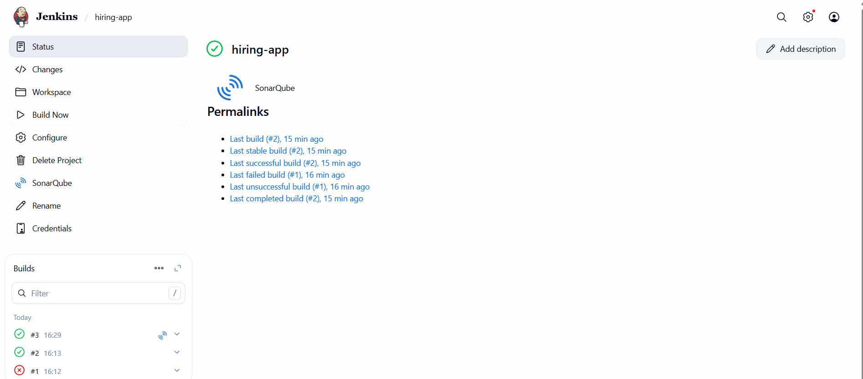

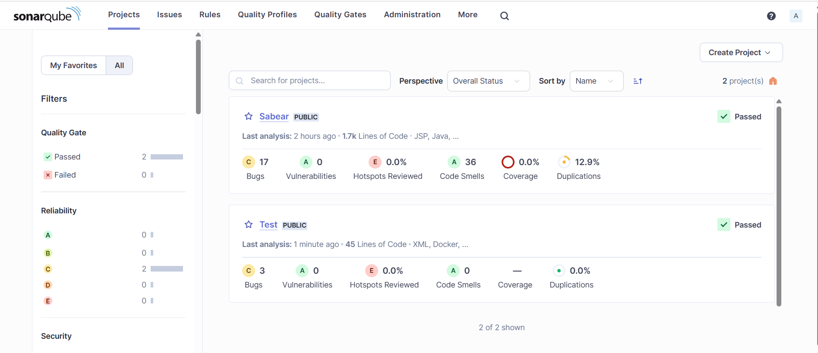
stage3: Slack Integration to send the alerts to slack.
Select Test connection it will be integrated in Slack.

